# **Beginner level Task – Visualization Library Documentation**

# Name: Lone Pravali

# Domain : Data Science

# Task level : Beginner

# Libraries chosen : Plotly and Bokeh

# VISUALIZATION

Visualization helps in better understanding and communication of data insights. While libraries like Matplotlib and Seaborn are popular, Plotly and Bokeh provide interactive and web-friendly visualization tools in python.

Let us dive deeper into Plotly and Bokeh.

## PLOTLY

Plotly is an open-source Python library used for creating interactive visualizations. It is built on top of D3.js, Stack.gl, and WebGL. Plotly allows zooming, panning, tooltips, and exporting directly from the browser.

plotly.py, colloquially referred to as Plotly, is an interactive, open-source, and browser-based graphing library. It offers Python-based charting, powered by plotly. js. The library ships with over 30 chart types, including scientific charts, 3D graphs, statistical charts, SVG maps, financial charts, and more.

### To get started:

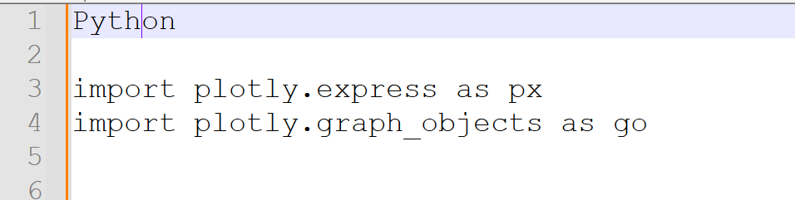

Some of the plots in Plotly:

### LINE CHART

Line plots are the basic charts where dot consecutive points are connected by a continuous line.

The default plot() is used for line charts.

Code snippet:

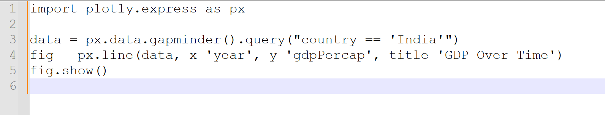

Output:

Here comes your visualization of India’s GDP per capita over time—just like you'd see from Plotly in Python.

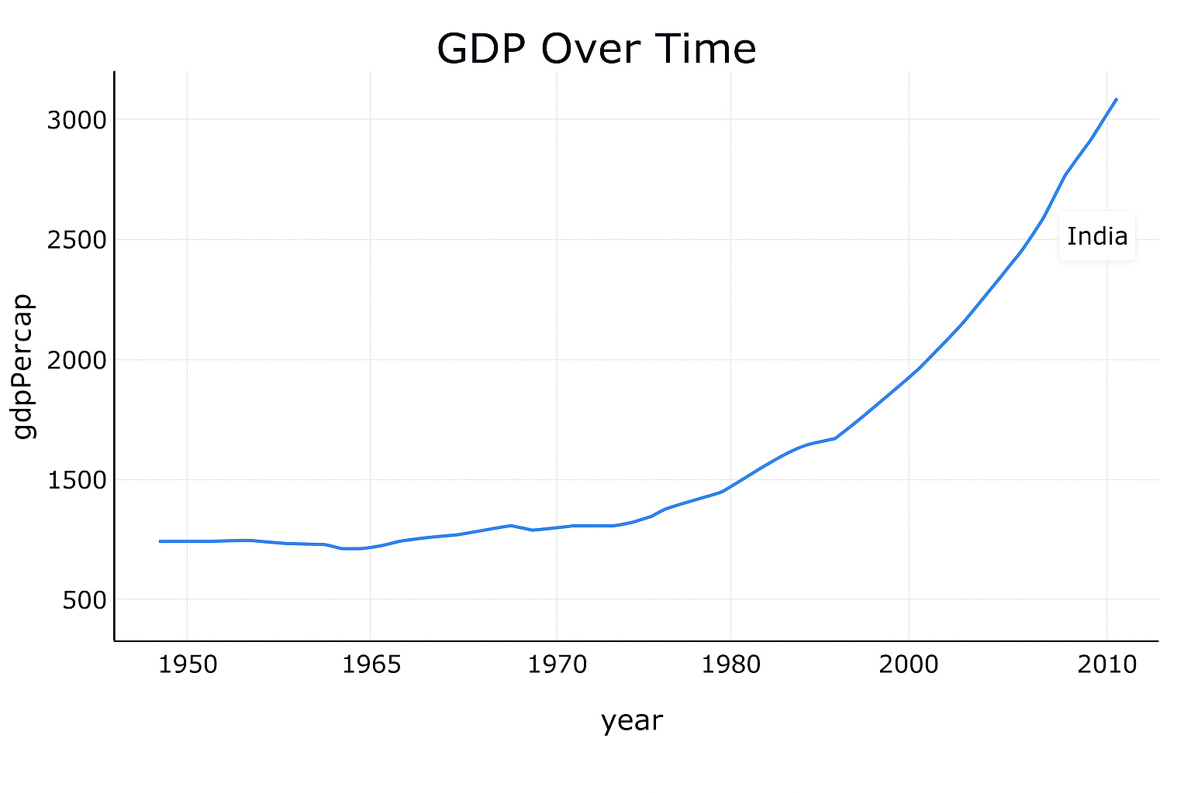

Description:

np.array() will generate an array in the specified range.

plot() for the plotting the line chart.

title() for defining the title, ylabel() and xlabel () for labelling y and x axis respectively.

show() displays the graph.

### BAR CHART

Rectangular bars are used in bar chart as the height represent the frequency of a particular element. bar () is used for plotting bar graphs, it has parameters like x, y, width, colour.

bar (x, y, colour, width)

Code snippet:

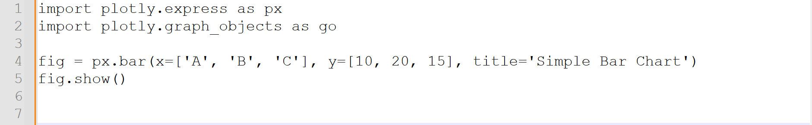

Output:

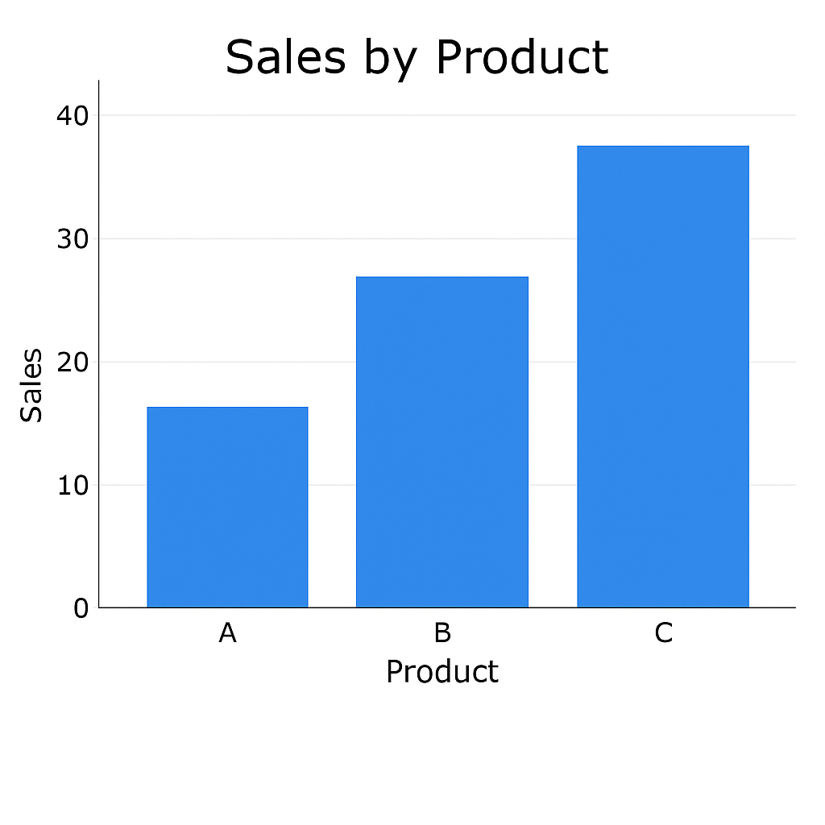

Description:  
random.rand(5) generates a random array.

Here bar () is used along with the parameters, width which denoted the width of the rectangular bars and colour for the bars.

### SCATTER PLOT

A scatter plot is a graph that uses dots to represent values for two different numeric variables. It visually displays the relationship between these variables, showing how changes in one variable correspond to changes in the other. The position of each dot on the graph indicates the values for an individual data point.

Code snippet:

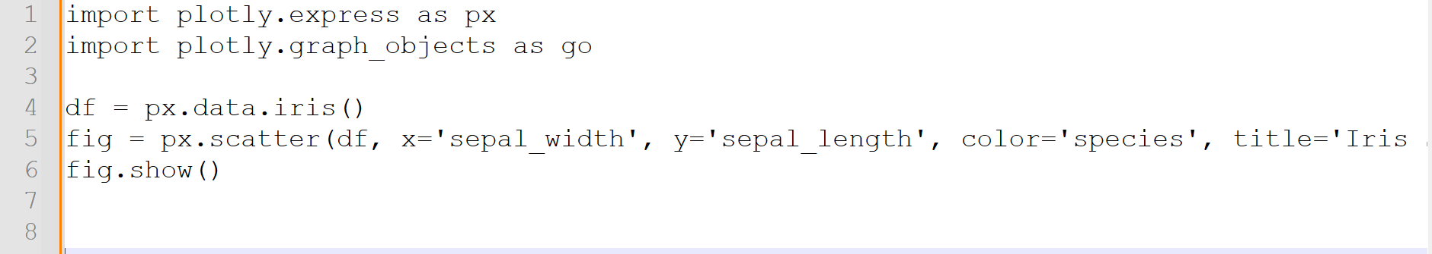

Output:

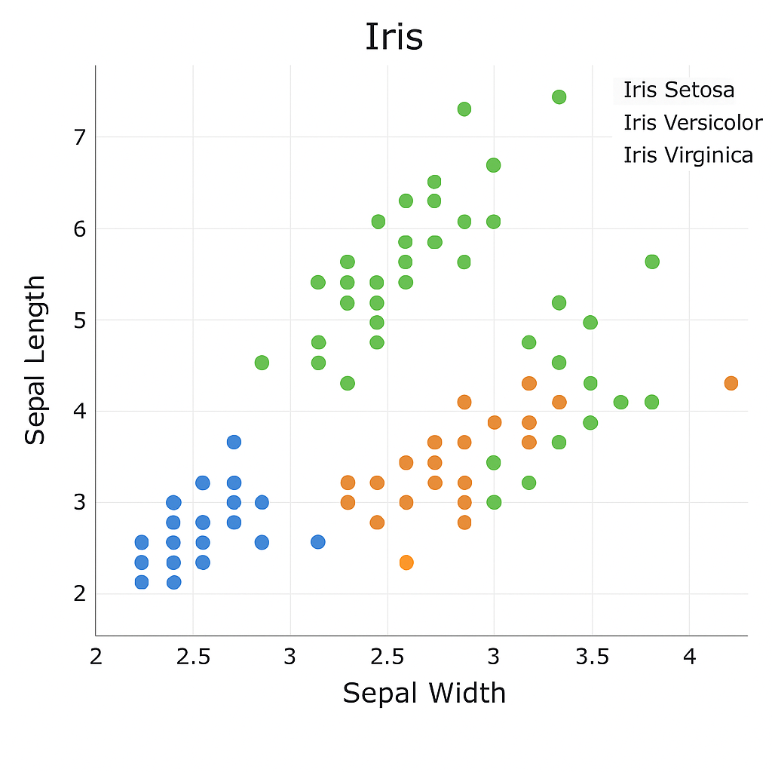

Description:

Scatter plot coloured by species in the famous iris dataset.

Legend adds the label which helps to differentiate the plots.

### PIECHART

Pie charts are used to plot data of same kind which means the same series of data where the different elements are divide based on their percentage.

Code snippet:

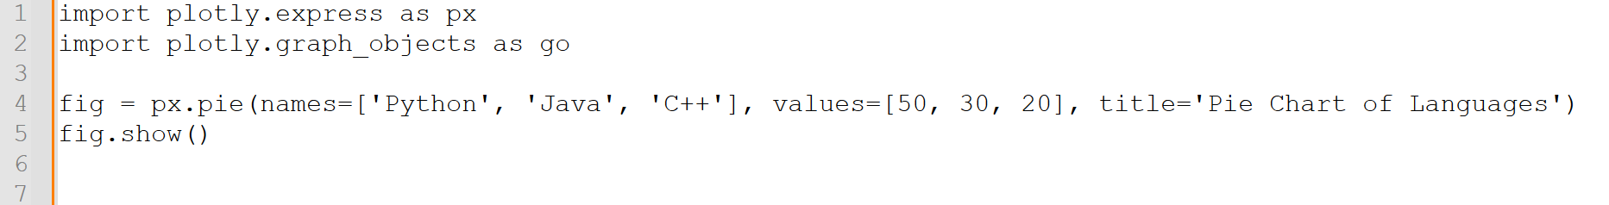

Output:

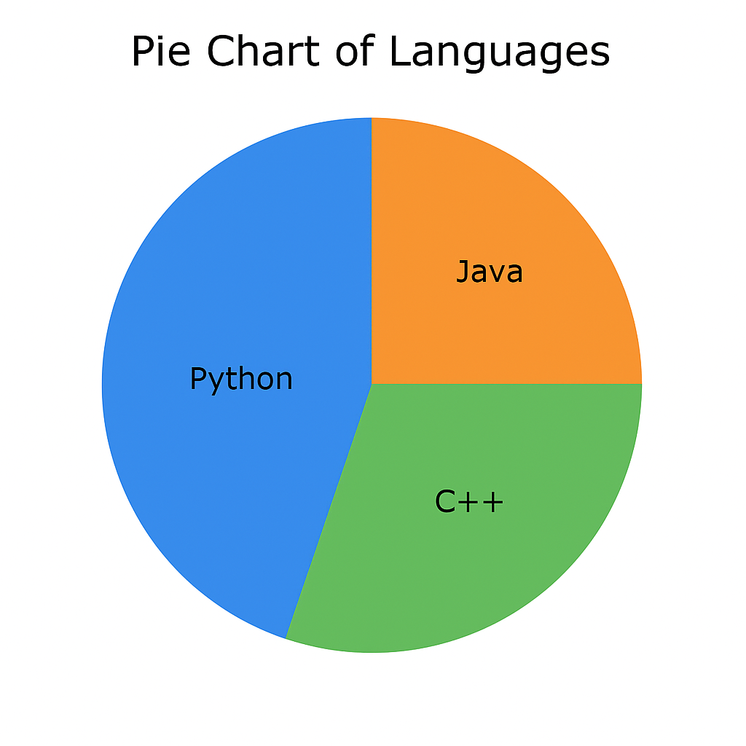

Description:

Here in the code, time is the x variable and labels are defined using labels keyword.

wedge props attribute is used to define the linewidth and the colour to separate the elements in the pie chart.

colour array contains the colours to each element.

### HISTOGRAM

Histogram is a type of bar graph where the graph is represented in groups. hist () is used for plotting histogram with parameters x, bins, colour, Edgemoor.

Code snippet:

Using fill between () function

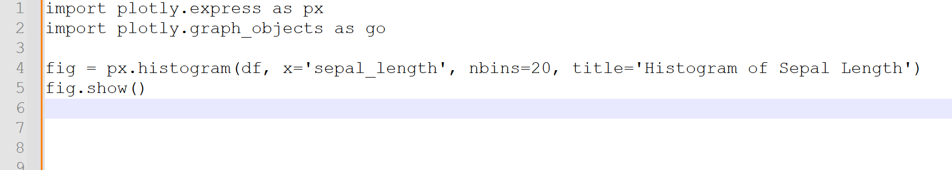

Output:

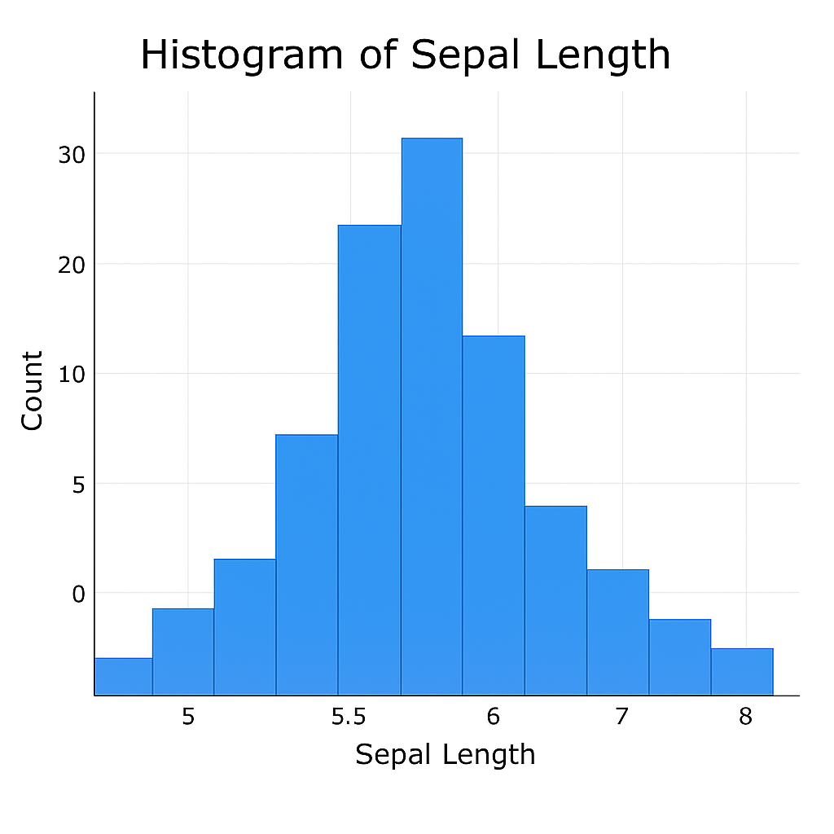

Description:

Histogram with 20 bins visualizing the distribution of sepal length.

### BOX PLOT

A box plot is a statistical representation of the distribution of a variable through its quartiles. The ends of the box represent the lower and upper quartiles, while the median (second quartile) is marked by a line inside the box. For other statistical representations of numerical data, see other statistical charts.

Code Snippet:

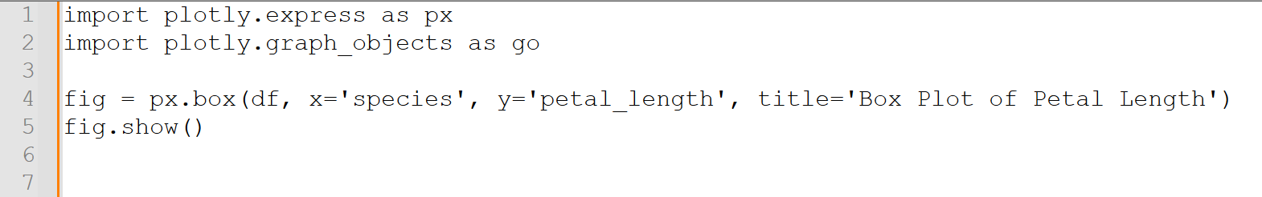

Output:

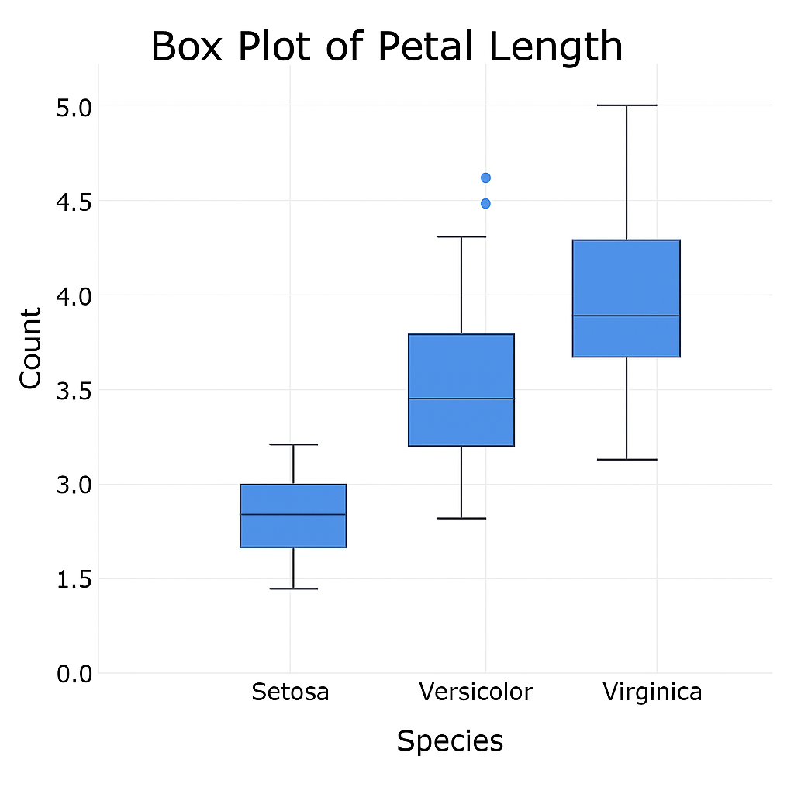

Description:

Box plot comparing petal lengths of different species in the iris dataset.

### BOKEH

**Bokeh** is another powerful library used for creating **interactive visualizations** in web browsers. It supports high-performance interactive plots rendered in HTML and JavaScript.

Let us see the different plots in each category.

### To get started:

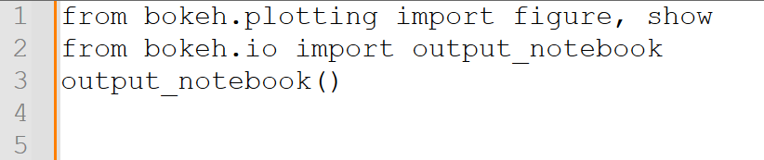

Here are some sample codes for some of the graphs.

### SCATTER PLOT:

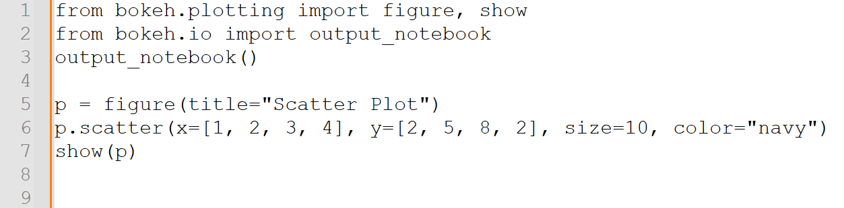

Output:

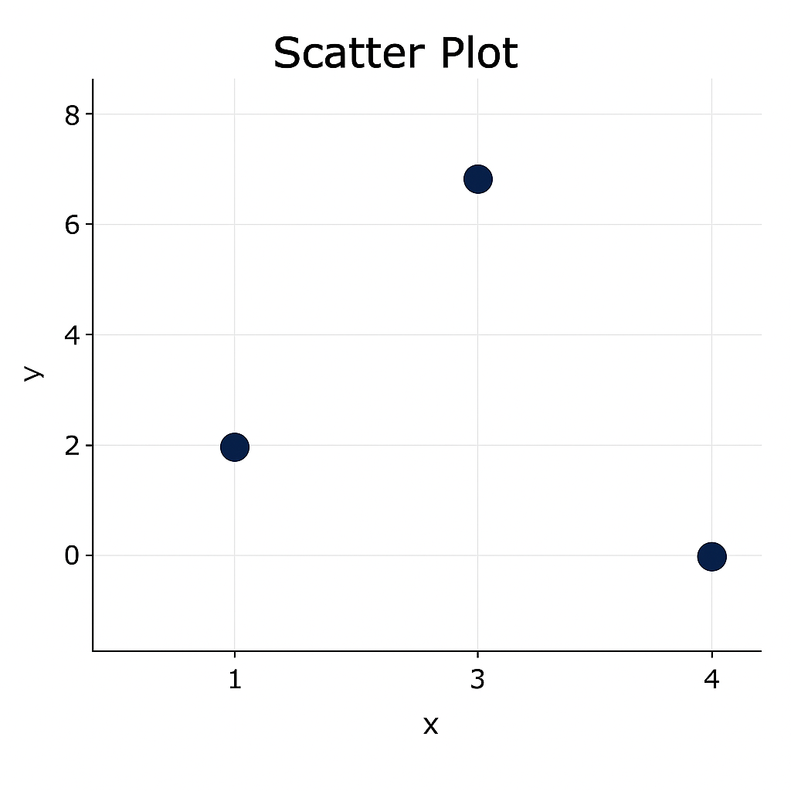

Description:

Dots plotted on x-y plane using scatter ().

LINE PLOT

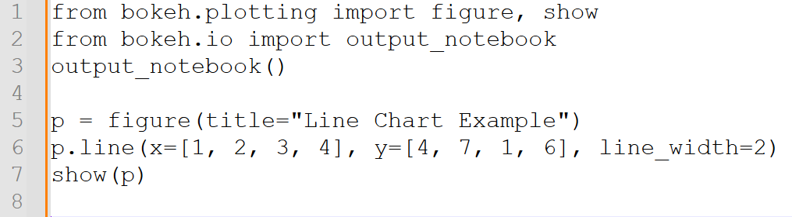

Output:

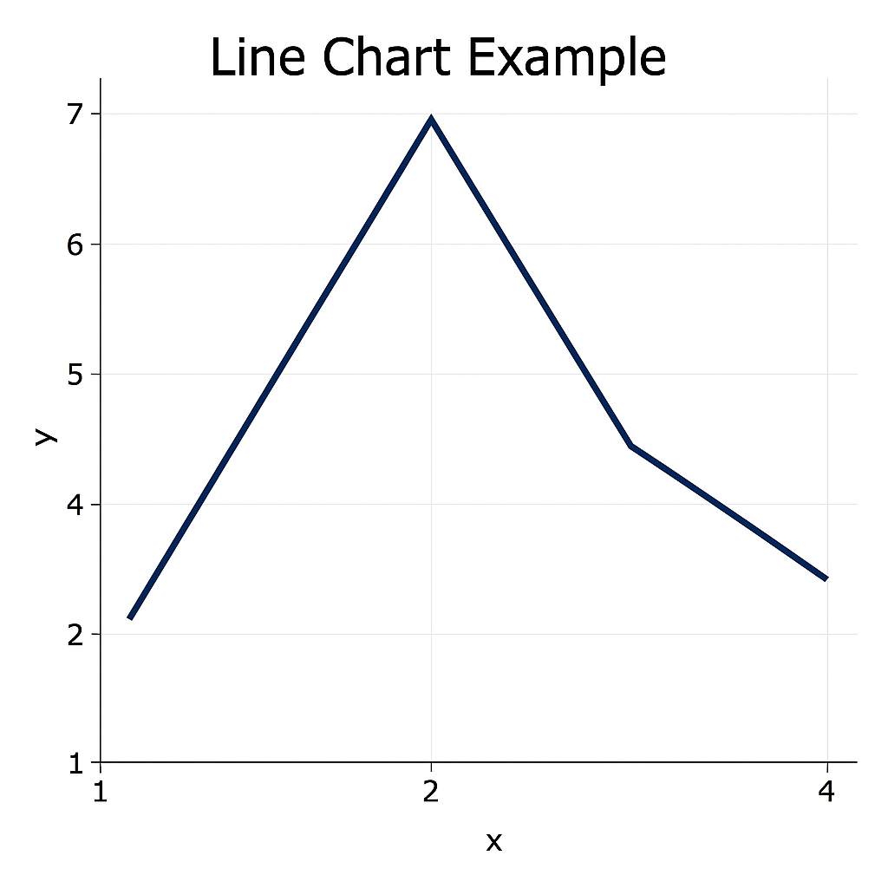

Description:

Simple line plot using Bokeh’s figure and line ().

BAR CHART

A bar plot, also known as a bar chart, is a graphical representation of data using rectangular bars. The length or height of each bar corresponds to the value it represents.

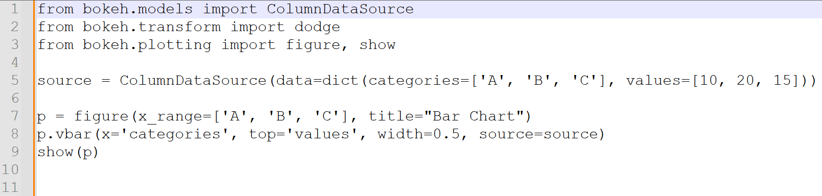

Output:

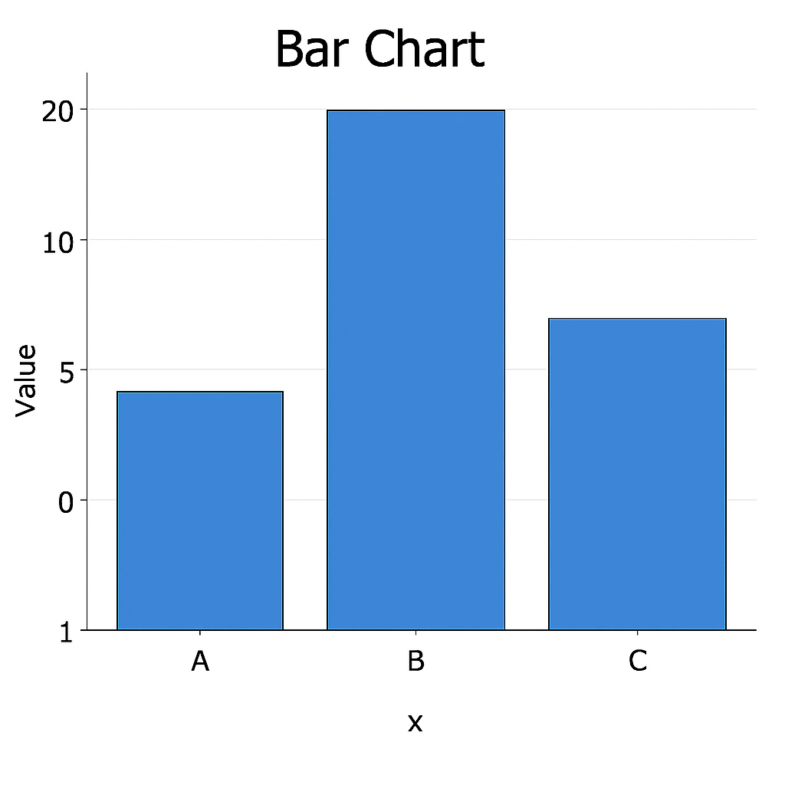

Description:

Vertical bars for categories using vbar().

### PIE CHART

A pie chart is a circular statistical graphic, divided into slices to illustrate numerical proportion. Each slice represents a proportion of the whole, visually demonstrating how different categories contribute to a total.

Code snippet:

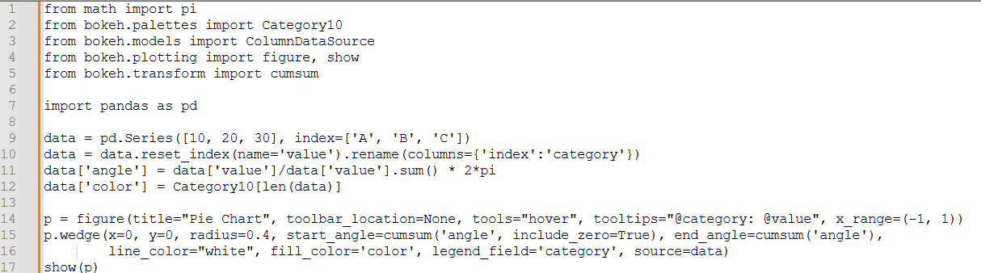

Output:

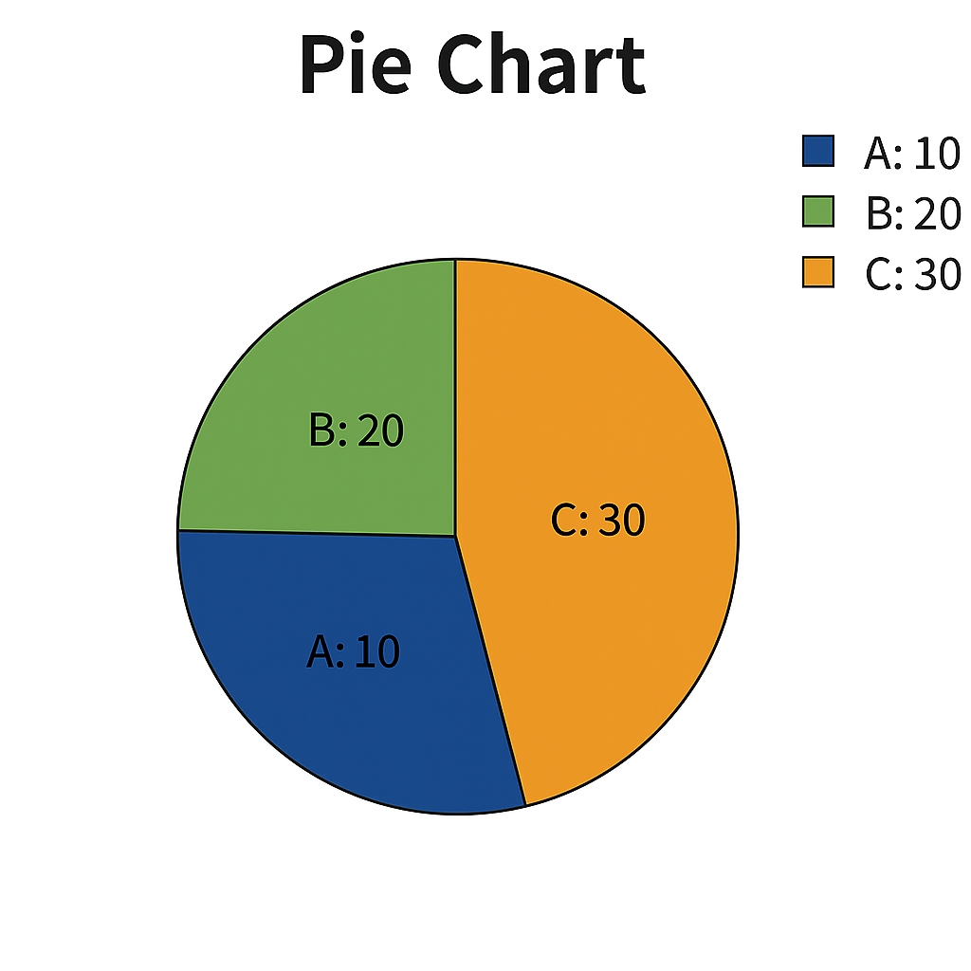

Description:

Creates a pie chart using wedge function.

### HISTOGRAM

A histogram is a graphical representation of the distribution of numerical data. It uses bars to show how often different values or ranges of values (bins) occur in a dataset.

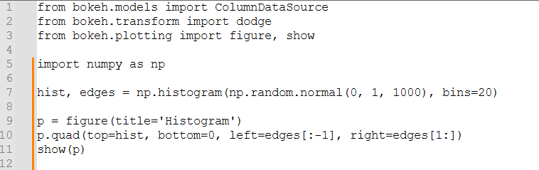

Output:

### SCATTER PLOT

Code snippet:

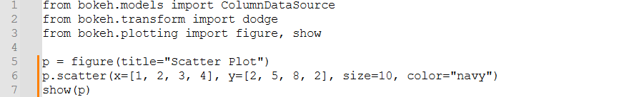

Output:

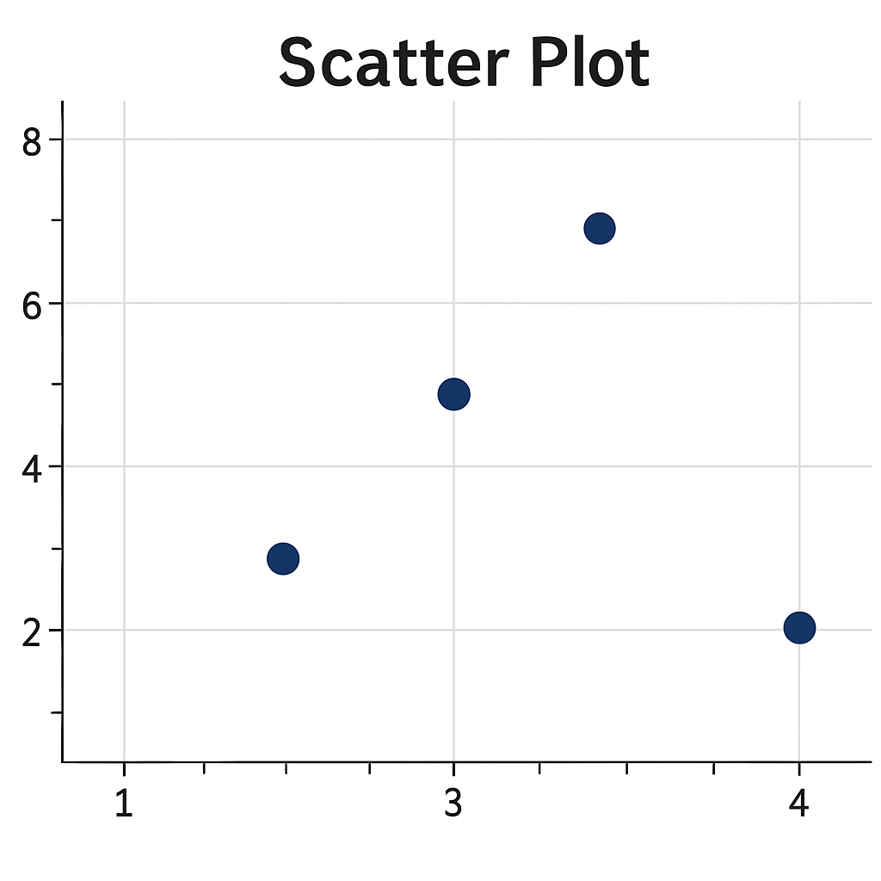

Description:

Dots plotted on x-y plane using scatter().

### COMPARISON OF PLOTLY AND BOKEH

**Plotly:**

* Core Library: Plotly is a versatile library for creating interactive and publication-quality visualizations in Python and JavaScript. It supports a wide range of chart types including scatter plots, line charts, bar charts, 3D plots, maps, and dashboards.
* Interactivity: One of Plotly’s key strengths is its built-in interactivity. Users can zoom, pan, hover, and click for additional information, making it ideal for web-based data visualization and dashboards.
* Ease of Use: Plotly Express (a high-level wrapper) allows users to quickly create visualizations with concise syntax. It is especially helpful for rapid prototyping and exploratory data analysis.
* Customization: Matplotlib offers extensive customization options, allowing users to customize every aspect of a plot, including colours, line styles, markers, fonts, annotations, and more.
* Web Integration: Plotly charts are rendered using D3.js and WebGL, making them highly interactive and suitable for web applications. It integrates well with frameworks like Dash for building analytical web apps.
* Aesthetic Control: Plotly provides beautiful default styles, along with detailed options for customizing layout, themes, colours, axes, and annotations.
* Export Options: Visualizations can be exported as static images (PNG, SVG, PDF) or embedded as interactive HTML components.
* **Advantages of Plotly:**
* Rich interactivity with zoom, hover, and clickable elements.
* Easy integration with web frameworks like Dash.
* Ability to export both static and interactive visualizations.

**Bokeh:**

* High-Level Interface: Bokeh is designed for creating interactive and web-ready visualizations in Python. It provides a flexible and powerful framework to build dashboards and browser-based plots.
* Interactivity and Widgets**:** Bokeh supports adding sliders, dropdowns, and other widgets to plots, allowing users to build interactive dashboards without needing JavaScript.
* StreamingandReal**-**TimeData**:** Bokeh excels at streaming and updating data in real-time, making it a good choice for applications that require live visualizations.
* Custom Layouts and Apps**:** Bokeh supports the creation of complex layouts (grids, tabs, rows/columns) and full interactive web applications using bokeh serve.
* Integration: Bokeh integrates well with Pandas and NumPy and supports linking plots together (e.g., brushing and linking across multiple plots).

**Advantages of Bokeh:**

* Powerful interactive tools and custom dashboard support.
* Built-in support for streaming and real-time data visualization.
* Integration with widgets and controls for full web apps.
* Standalone HTML export and server-side application support.

Overall, the choice between Plotly and Bokeh depends on the specific needs of the data visualization task. Plotly is preferred for its ease of use, rich interactivity, and visually appealing default styles, making it ideal for creating polished visualizations and dashboards. Bokeh, on the other hand, is favoured for building highly interactive web applications, real-time data streaming, each as needed.